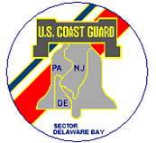
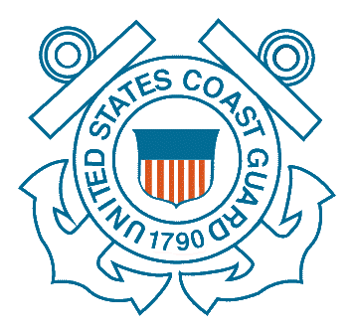
U.S. Coast Guard
Established Security Zones
Papal Visit 2015
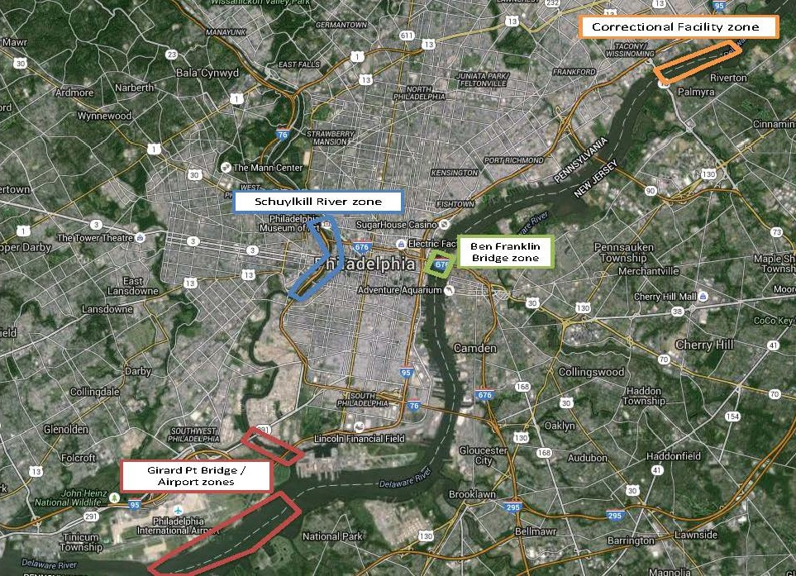

The U.S. Coast Guard will establish security zones on portions of the Delaware and Schuylkill Rivers during the Papal visit scheduled for Sept. 25-28, 2015. Vessel traffic will be restricted while the security zones are in effect to enhance security for Pope Francis, other dignitaries, and the public attending events throughout the weekend.

The following security zones will be enforced:

- Airport: Sept. 26 at 8 a.m. – 11 a.m.; Sept. 27 at 6 p.m. – 8 p.m.
All of the Delaware River from the east end of Little Tinicum Island to the mouth of the Schuylkill River.

- Schuylkill River: Sept. 25 at 6 a.m. – Sept. 28 at 2 a.m.
All waters of the Schuylkill River from the South 34th Street Bridge north and ending at the West Girard Avenue Bridge.

- I-95/Platt Bridge: Sept. 25 at 6 a.m. – Sept. 28 at 2 a.m.
All waters from the mouth of the Schuylkill River to 500 yards north of the George C. Platt Memorial Bridge.

- Benjamin Franklin Bridge: Sept. 26 at 6 a.m. – Sept. 28 at 2 a.m.
All waters extending from the Pennsylvania shoreline to the New Jersey Shoreline, extending from 39°56’31”N south of the bridge to 39°57’23”N north of the bridge. Vessels may be allowed to transit with escort through this security zone after an inspection.

- Curran-Fromhold Correctional Facility: Sept. 27, 9 a.m. to 2 p.m.
All water of the Delaware River adjacent to Curran-Fromhold Correctional Facility, in North-East Philadelphia, PA.

Boaters should monitor VHF-FM channel 16 on the days of the event for detailed information on waterway closures or restrictions, and allow for extra transit time. Entering or operating in a security zone is prohibited unless authorized by the U.S. Coast Guard.

